

API – Dark Sky

user guide V0.1



Contents

1. Introduction 3

2. Prerequisites 3

3. Configuration 4

4. Using the Business Object 5

4.1. Current 5

4.2. Time Machine 6

4.3. Daily 7

5. Support 9

6. Functional Tests 9

7. Troubleshooting Guidelines 10

8. Frequently Asked Questions 10

The information contained in this document is the proprietary and confidential information of Blue Prism Limited and should not be disclosed to a third party without the written consent of an authorised Blue Prism representative. No part of this document may be reproduced or transmitted in any form or by any means, electronic or mechanical, including photocopying without the written permission of Blue Prism Limited.

**© Blue Prism Limited, 2001 – 2020**®Blue Prism is a registered trademark of Blue Prism Limited

All trademarks are hereby acknowledged and are used to the benefit of their respective owners.  
Blue Prism is not responsible for the content of external websites referenced by this document.

Blue Prism Limited, Centrix House, Crow Lane East, Newton-le-Willows, WA12 9UY, United Kingdom  
Registered in England: Reg. No. 4260035. Tel: +44 870 879 3000. Web: www.blueprism.com

# Introduction

This asset is designed to provide connectivity from Blue Prism to the Dark Sky API for accurate weather forecasting and reference purposes. The API reference can be found at <https://darksky.net/dev/docs#overview>. This asset provides 3 services:

* Current Forecast – What is the weather like right now?
* Time Machine – A forecast for a specific date in the past or future.
* Daily Forecast. A forecast for today.

# Prerequisites

To use this asset, you require a licenced Blue Prism installation or trial. More information on Blue Prism can be found here.

<https://www.blueprism.com>

You will also require the **Utility – Date and Time Manipulation** asset. This is another DX Asset and is available for download here if it is not installed into your Blue Prism application. <https://digitalexchange.blueprism.com/dx/entry/9648/solution/date-and-time-manipulation>

Note that the asset mentioned above is different to the one that comes with Blue Prism. The one on the DX has 2 additional functions, Unix time epoch conversions, that are needed by this asset.

You will also require an internet connection. This is not supplied by Blue Prism. Please note that usage of this asset over a mobile connection may incur data charges. Blue Prism is not responsible for these charges. Your usage of this asset is acceptance of your understanding of these matters.

The asset is provided upon the understanding that the user has their own subscription to the Dark Sky API service. No subscription to this service is provided by Blue Prism. For pricing, please see the Dark Sky API pages at <https://darksky.net/dev> The data sources used by Dark Sky can be found here <https://darksky.net/dev/docs/sources>

The asset is created as a *bprelease* file, so that it may be reviewed and edited as you find necessary. It is maintained on a best endeavours’ basis by *Blue Prism* however, user feedback is appreciated, and this can be in relation to issues or errors found and feature requests.

# Configuration

To use this asset, import the ***.bprelease*** file which contains the following:

* API – Dark Sky
* Dark Sky Test Process

As previously mentioned, there is a dependency on the **Utility – Date and Time Manipulation**. Ideally, if this isn’t installed into your Blue Prism application, do this before installing the Dark Sky asset.

The Dark Sky service requires an APIKey, this APIKey is unique to the user. It is free to obtain one, and the service offers a free tier that will allow you to develop your service with up to 1000 calls per day. Beyond this limit the service becomes chargeable.

This API makes use of latitude and longitude coordinates. These can be provided by mapping services etc. There will be a VBO available soon for generating these coordinates directly from an address. Visit the Digital Exchange for new assets regularly.

# Using the Business Object

The Dark Sky API contains the following actions:

## Current

Inputs

| Name | Description | Data Type |
| --- | --- | --- |
| Latitude | The latitude coordinate for the location that the weather report is required. | Number |
| Longitude | The longitude coordinate for the location that weather report is required. | Number |

Outputs

| Name | Description | Data Type |
| --- | --- | --- |
| Summary | Textual description of the current weather. | Text |
| Time | The time that the weather forecast is supplied for. | Number |
| DateTime | The username by which you will access the Postgres database system | Text |
| precipProbability | The % probability of precipitation. | Number |
| precipIntensity | Linear depth per hour in mm per hour. | Number |
| nearestStormDistance | Nearest Storm in units. | Number |
| nearestStormBearing | Nearest Storm bearing in degrees from supplied Lat/Long Coordinates. | Number |
| dewPoint | Dewpoint Temperature | Number |
| pressure | Atmospheric Pressure in milibars. | Number |
| windSpeed | Wind Speed in MPH | Number |
| windBearing | Wind Bearing In Degrees | Number |
| windGust | Wind Gust in MPH | Number |
| apparentTemperature | Feels like – Temperature. | Number |
| temperature | Actual Temperature | Number |
| cloudcover | % cloud cover. | Number |
| humidity | Humidity value in grams per cubic metre. | Number |
| visibility | Visibility Distance (in units) | Number |
| uvIndex | No specific units but 0-2 (Low) 3-5(Moderate)6-7(High)8-10(V.High)11+(Extreme) | Number |
| ozone | Dobson units 1 DU is 0.01mm thickness at Standard Temperature and Pressure. | Number |

## Time Machine

Provides a weather report for a specific lat/long and date and time. The time value can be historical.

Inputs:

| Name | Description | Data Type |
| --- | --- | --- |
| Latitude | The latitude coordinate for the location that the weather report is required. | Text |
| Longitude | The longitude coordinate for the location that weather report is required. | Text |
| time | A Unix time value integer that reflects the number of seconds since 1/1/1970. | Text |

Outputs

| Name | Description | Data Type |
| --- | --- | --- |
| Summary | Textual description of the current weather. | Text |
| Time | The time that the weather forecast is supplied for. | Number |
| DateTime | The username by which you will access the Postgres database system | Text |
| precipProbability | The % probability of precipitation. | Number |
| precipIntensity | Linear depth per hour in mm per hour. | Number |
| precipType | The description of the type of precipitation. Raid, Sleet, Snow etc. | Text |
| nearestStormDistance | Nearest Storm in units. | Number |
| nearestStormBearing | Nearest Storm bearing in degrees from supplied Lat/Long Coordinates. | Number |
| dewPoint | Dewpoint Temperature | Number |
| pressure | Atmospheric Pressure in milibars. | Number |
| windSpeed | Wind Speed in MPH | Number |
| windBearing | Wind Bearing In Degrees | Number |
| windGust | Wind Gust in MPH | Number |
| apparentTemperature | Feels like – Temperature. | Number |
| temperature | Actual Temperature | Number |
| cloudcover | % cloud cover. | Number |
| humidity | Humidity value in grams per cubic metre. | Number |
| visibility | Visibility Distance (in units) | Number |
| uvIndex | No specific units but 0-2 (Low) 3-5(Moderate)6-7(High)8-10(V.High)11+(Extreme) | Number |
| ozone | Dobson units 1 DU is 0.01mm thickness at Standard Temperature and Pressure. | Number |

## Daily

A daily weather forecast for a specific date/time/location.

Inputs:

| Name | Description | Data Type |
| --- | --- | --- |
| Latitude | The latitude coordinate for the location that the weather report is required. | Text |
| Longitude | The longitude coordinate for the location that weather report is required. | Text |
| time | A Unix time value integer that reflects the number of seconds since 1/1/1970. | Text |

Outputs:

| Name | Description | Data Type |
| --- | --- | --- |
| Summary | Textual description of the current weather. | Text |
| Time | The time that the weather forecast is supplied for. | Number |
| sunriseTime | The sunrise time for the provided location parameters. | Number |
| sunsetTime | The sunset time for the provided location parameters. | Number |
| moonPhase | Number of days since the most recent full moon. | Number |
| precipProbability | The % probability of precipitation. | Number |
| precipIntensity | Linear depth per hour in mm per hour. | Number |
| precipIntensityMax | The maximum amount of precipitation fallen in mm. |  |
| precipIntensiryMaxTime | The time by which the maximum precipitation will have fallen. | Number |
| precipType | The description of the type of precipitation. Raid, Sleet, Snow etc. |  |
| nearestStormDistance | Nearest Storm in units. | Number |
| nearestStormBearing | Nearest Storm bearing in degrees from supplied Lat/Long Coordinates. | Number |
| dewPoint | Dewpoint Temperature | Number |
| pressure | Atmospheric Pressure in milibars. | Number |
| windSpeed | Wind Speed in MPH | Number |
| windBearing | Wind Bearing In Degrees | Number |
| windGust | Wind Gust in MPH | Number |
| apparentTemperature | Feels like – Temperature. | Number |
| temperature | Actual Temperature | Number |
| cloudcover | % cloud cover. | Number |
| humidity | Humidity value in grams per cubic metre. | Number |
| visibility | Visibility Distance (in units) | Number |
| uvIndex | No specific units but 0-2 (Low) 3-5(Moderate)6-7(High)8-10(V.High)11+(Extreme) | Number |
| ozone | Dobson units 1 DU is 0.01mm thickness at Standard Temperature and Pressure. | Number |
| temperatureLow | The overnight low temperature | Number |
| temperatureMax | The Maximum temperature for the day | Number |
| temperatureHigh | The overnight high temperature. | Number |
| temperatureHighTime | The time the high temperature is recorded. | Number |
| apparentTemperatureLow | The apparent (feels like) temperature low. | Number |
| apparentTemperatureLowTime | The apparent (feels like) temperature low time. | Number |
| temperatureMin | The minimum daytime temperature. | Number |
| temperatureMinTime | The minimum temperature time. | Number |
| temperatureLowTime | The time the overnight low temperature was recorded. | Number |
| temperatureMaxTime | The overnight max temperature time. | Number |
| apparentTemperatureMin | The feels-like temperature min. | Number |
| apparentTemperatureMax | The feels like temperature max. | Number |
| apparentTemperatureHigh | The feels like temperatures high. | Number |
| apparentTemperatureMaxTime | The feels like temperature max time. | Number |
| apparentTemperatureMinTime | The feels like temperature min time. | Number |
| apparentTemperatureHighTime | The feels like temperature high time. | Number |

The Dark Sky Test Process has several conversion routines to convert the Unix time values to more human readable Date-Time values. These are done using the additional Utility – Date Time Manipulation asset mentioned previously, available on the DX at <https://digitalexchange.blueprism.com/dx/entry/9648/solution/date-and-time-manipulation>.

# Support

Support for this skill is provided via the Blue Prism Digital Exchange Community Forum. Post your questions here:

[Digital Exchange Community Forum](https://community.blueprism.com/communities/community-home?communitykey=1e516cfe-4d1f-4de9-a9eb-58d15bf38c81&tab=groupdetails)

# Functional Tests

There is a simple test process for each of the functions however the user should satisfy themselves that the results are both correct and satisfactory for their needs. Usage of these functions reflects that satisfaction. To make use of these tests, locate the Dark Sky Test process and open it in process studio. Your personal API key for the Dark Sky API service can be entered in the provided DarkSkyAPI Credential.

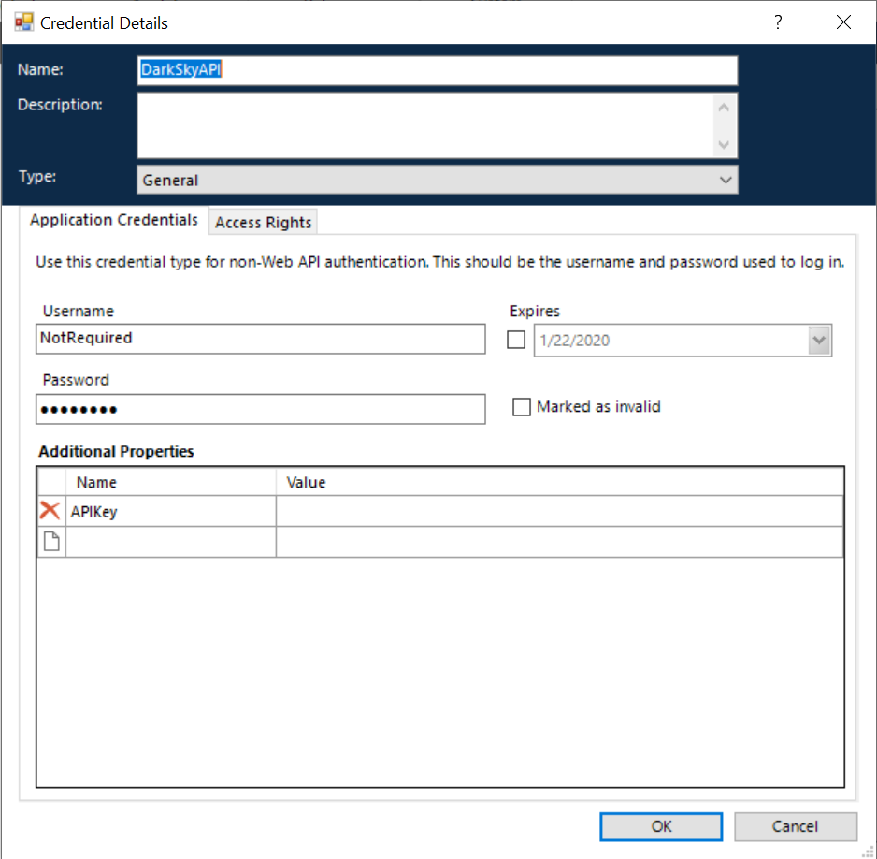

It will be necessary to give the credential some access rights.

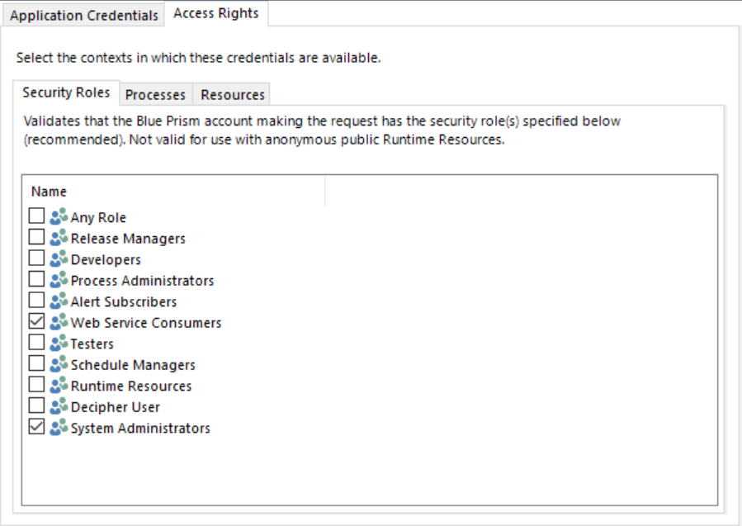

These are best applied to whatever suits your needs.

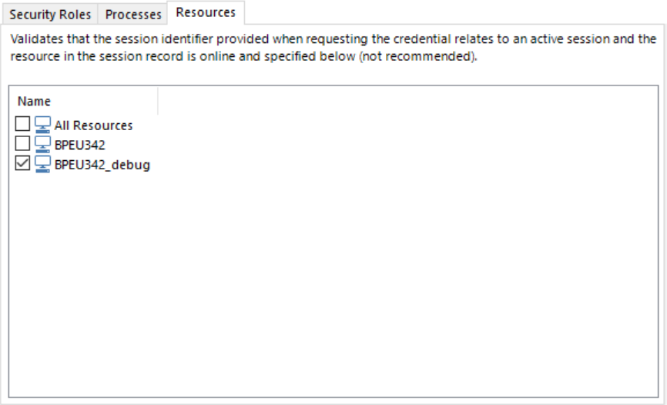

Resource allocation is again up to your requirements as to where the process will run.

The credential data is retrieved using the built in Credential object that was installed with Blue Prism. Examples of its use are provided in the Dark Sky Test process.

# Troubleshooting Guidelines

There are no known commonly encountered issues at this stage, or corresponding resolutions for them. If users begin encountering issues, then this section will be updated with known resolutions.

It should be noted that this asset was built against the standard PostgreSQL download. It has not been tested against any other version neither hosted or cloud.

# Frequently Asked Questions

There are no frequently asked questions at this stage.